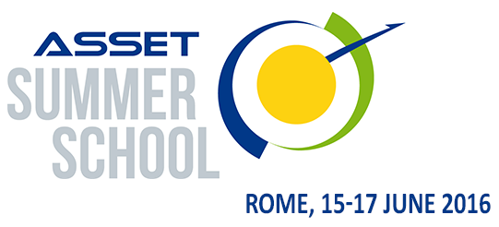
Form for Application
In order to register for the 2nd edition of the ASSET Summer School, please complete the application form here below and send it to eva.appelgren@iss.it by April 20,2016. (the form can also be sent by fax at the following number +39-06-49904110)
The selection of the participant will be confirmed within May 5th, 2016.
ANAGRAPHIC DATA
First name:
Surname:
Place and Date of Birth:
Address :
Country:
Telephone number:
Email address:
EDUCATION AND TRAINING
Academic degree
WORK EXPERIENCE
Occupation or position held
Brief description of current work (max 200 words)
Name of Institution and locality
MOTIVATION FOR PARTCIPATION AND EXPECTED IMPACT ON YOUR FUTURE WORK
(max 300 words)
PERSONAL SKILLS
Proficiency level in English language (indicate if: basic, intermediate, advanced) | UNDERSTANDING SPEAKING WRITING  Listening Reading Spoken interaction Spoken production  _____________ _____________ ________________ ______________ _______________

